in one.html file:
<body class="bg-black">
<div >
<h1 id="title" class="heading">DOM Learning on Chai Code Video <span style="display: none;">Test Text</span></h1>
<p> DOM = Document Object Model</p>
</div>
</body>

--->inspect -->console
Get ElementById:-
document.getElementById("title")
>>>>> <h1 id='title' class="heading">DOM Learning on Chai Code Video</h1>

Get elements attributes separately:-
document.getElementById("title").id
>>>>>'title'

document.getElementById("title").className
>>>>>"heading"

Get Attributes:-
document.getElementById("title").getAttribute("id")
>>>>>'title'

document.getElementById("title").getAttribute("class")
>>>>>"heading"

Set Attributes:-
document.getElementById("title").SetAttribute("id", "Test")
>>>>>Undefined
///Attributes changed
document.getElementById("title").getAttribute("id")
>>>>>"Test"

Save data in JS variable:-
Const title = document.getElementById("title")
>>>> Undefined
//Call the variable
Title
>>>>> <h1 id='title' class="heading">DOM Learning on Chai Code Video</h1>

Change the style by using js variable
title.style.backgroundColor = “Green”
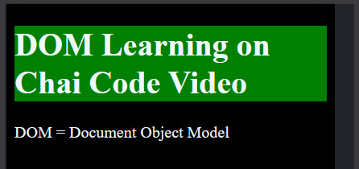
title.style.backgroundColor = “red”


title.style.padding = "15px"
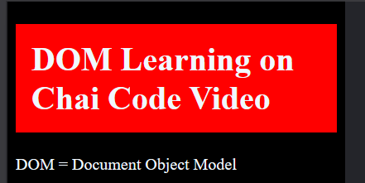
title.style.borderRadius = "15px"
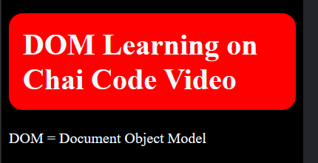

After Editing the variable value:-
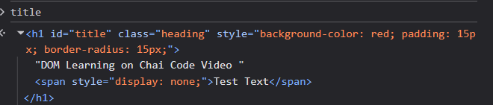

Now, get the “---” value from the title variable
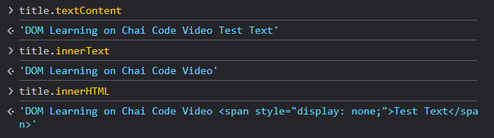

Difference between innertext and innercontent is
innerText:- Only shows the visible text
innerContent:- Shows the text even if it is transparent by CSS properties

querySelector/querySelectorAll

Get Element by “querySelector”:-
document.querySelector('h1')
>>>> <h1 id="title" class="heading">DOM Learning on Chai Code Video <span style="display: none;">Test Text</span></h1>

Use “#” for id
document.querySelector('#title')
>>>> <h1 id="title" class="heading">DOM Learning on Chai Code Video <span style="display: none;">Test Text</span></h1>

Use “.” for class
document.querySelector('.heading')
>>>> <h1 id="title" class="heading">DOM Learning on Chai Code Video <span style="display: none;">Test Text</span></h1>

For Input type:-
Html:- <input type="password" name="" id="">
document.querySelector('input[type="password"]')
>>>><input type="password" name="" id="">
////////////////////////////////////////////////////////////////////////////////////
Take an item from an list an edit it:-
HTML:-
<ul>
<li>one </li>
<li>two</li>
<li>three</li>
</ul>
const myUl = document.querySelector('ul')
const one = myUl.querySelector('li')
one.style.backgroundColor="Green"
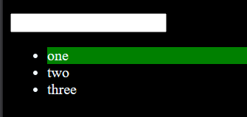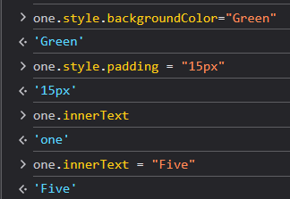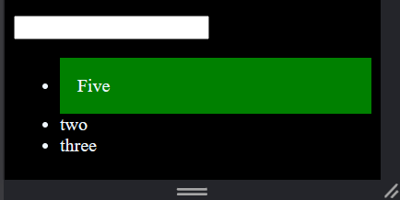

querySelectorAll:-
document.querySelectorAll('li')
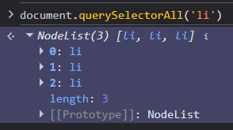
const tempLiList = document.querySelectorAll('li')
tempLiList[0].style.color="green"
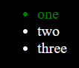
mylist.forEach((li) =>{
li.style.backgroundColor = "yellow"
})
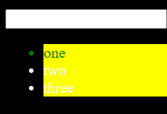
getElementByClassName:-
html:-
<ul>
<li class = "list-item">one </li>
<li class = "list-item">two</li>
<li class = "list-item">three</li>
<li class = "list-item">four</li>
</ul>
Const tempList = document.getElementsByClassName("list-item")
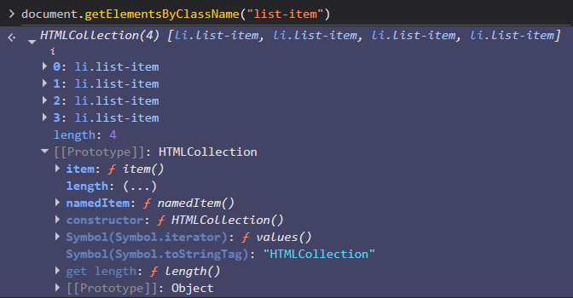
No forEach ,so:-
const myConvertedArray = Array.from(tempList)
myConvertedArray
myConvertedArray.forEach((li) =>{
li.style.backgroundColor = "green"
})
